Syed Muhammad Mehmaam

2018-CS-155

Section C

**LAB 02**

**Exercise 1**

Design a class diagram of an *Order System* of an application. So it describes a particular aspect of the entire application. Draw class diagram considering all the points mentioned below:

* First of all *Order* and *Customer* are identified as the two elements of the system and they have a *one to many* relationship because a customer can have multiple orders.
* We would keep *Order* class is an abstract class and it has two concrete classes (inheritance relationship) *SpecialOrder* and *NormalOrder*.
* The two inherited classes have all the properties as the *Order* class. In addition they have additional functions like *dispatch ()* and *receive ()*.

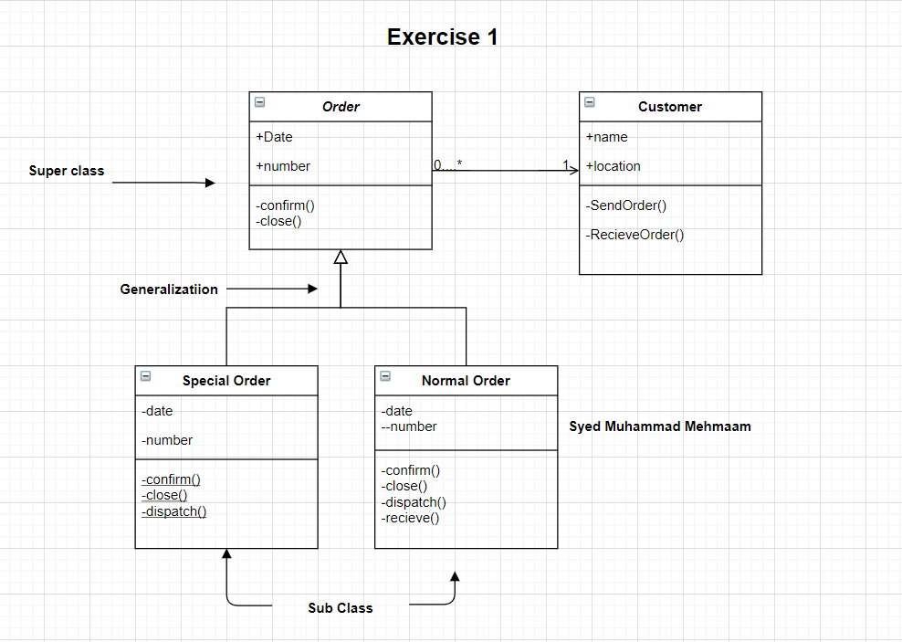

**Exercise 2**

Design a class diagram for the transactions of bank (Considering only checking balance, withdraw cash and deposit cash for the sake of simplicity.

